NFC-IET UNIVERSITY, MULTAN



LAB REPORT

ICT (“Information & Communication Technology Fundamental”)

For the degree of Bacheller of Science

In Computer Science

Session [2k24]

**Name MUHAMMAD RIZWAN**

**Roll NO 2K24-BSCS-409**

**Section Y**

**Submitted To: Mrs. Fabia Hassan**

**Submitted By: Muhammad Rizwan**

December 2024

**LAB 1**

**TYPING Practice**

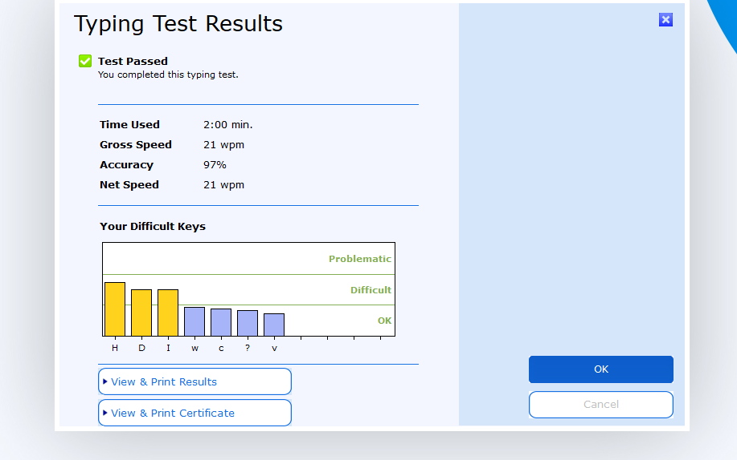

Topic sentences are similar to mini thesis statements. Like a thesis statement, a topic sentence has a specific main point. Whereas the thesis is the main point of the essay, the topic sentence is the main point of the paragraph. Like the thesis statement, a topic sentence has a unifying function. But a thesis statement or topic sentence alone doesn’t guarantee unity. An essay is unified if all the paragraphs relate to the thesis, whereas a paragraph is unified if all the sentences relate to the topic sentence. Note: Not all paragraphs need topic sentences. In particular, opening and closing paragraphs, which serve different functions from body paragraphs, generally don’t have topic sentences.

In academic writing, the topic sentence nearly always works best at the beginning of a paragraph so that the reader knows what to expect:

The embrace of Twitter by politicians and journalists has been one of its most notable features in recent years: for both groups the use of Twitter is becoming close to a requirement.

—Paul Bernal, “A defence of Responsible Tweeting”

This topic sentence forecasts the central idea or main point of the paragraph: “politicians” and “journalists” rely on Twitter. The rest of the paragraph will focus on these two Twitter-user groups, thereby fulfilling the promise made by the topic sentence. By avoiding irrelevant information that does not relate to the topic sentence, you can compose a unified paragraph

**Internal Components Of Computer**

**A computer is a complex machine composed of various interconnected components. Here are the primary internal components that work together to process information:**

**1. Central Processing Unit (CPU):**

* **Often referred to as the "brain" of the computer.**
* **Executes instructions and performs calculations.**
* **Divided into two main units:**
  + **Control Unit (CU): Coordinates and controls the operations of the computer.**
  + **Arithmetic Logic Unit (ALU): Performs arithmetic and logical operations.**

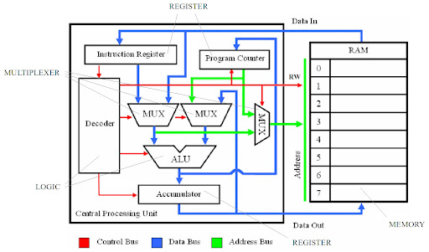

**2. Motherboard:**

* **The main circuit board that connects all the internal components.**
* **Provides the electrical pathways for communication between components.**
* **Houses various expansion slots for additional hardware.**

**3. Random Access Memory (RAM):**

* **Temporary storage for data and instructions that the CPU is currently using.**
* **Volatile memory, meaning data is lost when the power is turned off.**
* **Random Access Memory (RAM)**
* **Random Access Memory, commonly referred to as RAM, is a critical component of modern computing systems, responsible for temporarily storing data that the CPU needs to process tasks efficiently. Its role is essential in determining the performance of devices, wheth4. Storage Devices:**
* **Hard Disk Drive (HDD): Stores large amounts of data permanently.**
* **Solid-State Drive (SSD): Faster and more reliable than HDDs.**
* **Optical Drives: Used for reading and writing data on CDs, DVDs, or Blu- ray discs.**
* **Storage Devices: An Overview**
* **Storage devices are a fundamental component of modern computing systems, designed to store and retrieve digital information. They have evolved over the decades in terms of capacity, speed, reliability, and portability. Understanding storage devices is essential in fields ranging from personal computing to enterprise-level IT infrastructure.**

**4. Storage Devices:**

* **Hard Disk Drive (HDD): Stores large amounts of data permanently.**
* **Solid-State Drive (SSD): Faster and more reliable than HDDs.**
* **Optical Drives: Used for reading and writing data on CDs, DVDs, or Blu- ray discs.**

**LAB 2**

**System requirements for installing Windows 10**

To install Windows 10, you need to make sure your PC meets the minimum system requirements:

* **Processor**: 1GHz or faster
* **RAM:**1GB for 32-bit OS or 2GB for 64-bit OS
* **Storage:**16GB for 32-bit OS or 20GB for 64-bit OS
* **Graphics card:**DirectX 9 graphics device with WDDM (Windows Display Driver Model) driver
* **Display:**800x600 resolution
* **Network:**Internet connection
* **Step 1:** Download and Open Windows 10 installation media from Microsoft Website.
* **Step 2:** Accept license terms by choosing Accept.

**Step 3:**Choose Create installation media and click Next.

**Step 4:**Click Next

**Step 5:**Choose USB flash drive and click Next to proceed. **Step 6:**Plug your USB Device into the Proceed.

**Step 6:**Plug your USB Device into the PC

**Step 7:**Select the drive to install Windows and click Next. This will erase and reformat the drive.

**Step 6:**Plug your USB Device into the Pc

**Step 7:**Select the drive to install Windows and click Next. This will erase and reformat the drive.

**Step 8:**Windows 10 is now being downloaded into your USB device. Wait until this process finishes and close the setup window.

**Step 9:**Plug your USB Device (as a bootable device now) with Windows 10 installer into a new PC.

**Step 10**: Turn on your new computer and access the BIOS/UEFI (typically using F2, F10, or Del).

**Step 11**: In BIOS/UEFI, set the USB flash drive as the first boot option.

**Step 12:**Save changes and exit. Your PC will reboot from the USB drive.

**Step 13:**When the Windows Setup appears, select language, time/currency format, etc. then choose Next.

**Step 14:**After that, Click Install Now and follow the prompts to set up Windows

**Type 2: Upgrading from an older Windows version**

You can also upgrade to Windows 10 from the older version of Windows while keeping files, settings, and programs. Here is how:

**Step 1:**Run the Windows 10 installation media.

**Step 2:**Choose Upgrade this PC now and click Next to start the upgrade.

**Step 3:**Now, Windows 10 Setup will begin the installation process

**Step 4:**Windows will install automatically while preserving files and settings.

CPU ASSEMBLING:

CPU assembling refers to the process of physically installing a CPU (Central Processing Unit) onto a motherboard. It's a crucial step in building or upgrading a computer.

**DIAGRAM:**

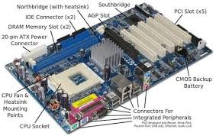

**Here's a general overview of the CPU assembly process:**

* + **Prepare the Motherboard:**

Ensure the motherboard is clean and free of any debris.

Locate the CPU socket on the motherboard. It's usually a square or rectangular socket with a protective cover.

* + **Install the CPU:**

Carefully remove the protective cover from the CPU socket.

Align the notches on the CPU with the corresponding keys on the socket.

Gently lower the CPU into the socket.

Close the socket lever or latch to secure the CPU in place.

**APPLY THERMAL PASTE**

Apply a small, pea-sized amount of thermal paste to the center of the CPU. Thermal paste helps to transfer heat from the CPU to the CPU cooler, preventing overheating.

* + **Install the CPU Cooler:**

Align the mounting brackets of the CPU cooler with the corresponding holes on the motherboard.

Secure the cooler using the provided screws or clips.

Connect the power cable from the CPU cooler to the motherboard.

**LAB 3**

**MOTHERBOARD** (THE BACKBONE OF COMPUTER)

A motherboard, often referred to as the mainboard or system board, is the primary circuit board within a computer. It houses and interconnects all the crucial components, enabling them to communicate and function together.

➢ **Key Components of a Motherboard:**

1. **CPU Socket:** This is where the Central Processing Unit (CPU) is installed. The socket type determines the compatible CPUs.
2. **RAM Slots:** These slots hold Random Access Memory (RAM) modules, which serve as short-term memory for the system.
3. **Chipset:** This integrated circuit controls the communication between the CPU, RAM, and other components. It's typically divided into the Northbridge and Southbridge chipsets.
4. **Expansion Slots:** These slots allow you to add expansion cards like graphics cards, sound cards, or network cards.
5. **BIOS Chip:** The Basic Input/Output System (BIOS) is a firmware that initializes the hardware components during the boot process.
6. **Power Supply Connector:** This connector supplies power to the motherboard and its components.
7. **Storage Device Connectors:** These connectors allow you to connect hard drives, SSDs, and other storage devices.
8. **I/O Ports:** These ports provide connectivity for various devices like keyboards, mice, USB drives, and external monitors.
9. **Heat Sink and Fan:** These components help dissipate heat generated by the CPU and other components.

**How it works?**

The motherboard acts as a central hub, facilitating communication between different components through a network of electrical pathways. When you turn on your computer, the BIOS initializes the hardware, loads the operating system, and transfers control to it. The CPU then executes instructions, processes data, and interacts with other components through the chipset.

**Choosing a Motherboard:**

When selecting a motherboard, consider the following factors:

* **Socket Compatibility:** Ensure it supports your desired CPU.
* **RAM Compatibility:** Check the supported RAM types and maximum capacity.
* **Expansion Slots:** Consider your future needs for additional cards.
* **Chipset:** A powerful chipset can improve overall performance.
* **Form Factor:** Choose a size that fits your case (e.g., ATX, Micro-ATX, Mini-ITX).
* **I/O Ports:** Select a motherboard with the necessary ports for your peripherals.

**VON NEUMAN ARCHITECTURE:**

* It was proposed by 1945

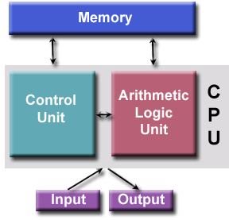

**Static Electricity:** Always ground yourself before handling computer components to avoid electrostatic discharge, which can damage sensitive components.

* **Thermal Paste:** Use a high-quality thermal paste and apply it correctly to ensure efficient heat dissipation.
* **CPU Cooler:** Choose a CPU cooler that is compatible with your CPU and motherboard.
* **Motherboard Manual:** Refer to your motherboard's manual for specific instructions on CPU installation and cooler mounting.

**LAB 4**

**MS WORLD ADVANCED FEATUERS:**

** Introduction to MS office:**

Microsoft Office is a suite of productivity applications developed by Microsoft. It's widely used in both personal and professional settings to create and edit documents, spreadsheets, presentations, and more. ➢ Key Components of Microsoft Office:

1. Microsoft Word:

1) A word processor used for creating and editing text documents. o You can format text, insert images, create tables, and much more.

2) Microsoft Word is a widely used word processing software developed by Microsoft. It allows users to create, edit, format, and print documents such as reports, letters, and resumes.

➢ Features of Microsoft Word:

Home, Insert, Design, Layout, Reference, Mailings, Review, View.

Uses of Microsoft Word:

3) Document Creation* Letters, Reports, CV Resumes, Essays,

Brochures, Newsletters, Meeting Agendas, Minutes, Proposals, Flyers, Invoices, Forms, Labels, Calendars, E-books, Templates, Web Pages, Books, Diaries and Journals & Scripts.

*Home Tab*

*Clipboard*: Cut, copy, paste, format painter.

*Font*:

Font style, size, bold, italic, underline, text color, highlighting.

*Paragraph*:

Alignment, indentation, line spacing, lists (bulleted/numbered), borders.

*Styles*:

Quick Styles, apply styles to text.

*Editing*:

➢ Find, replace, select. • Uses: Basic text formatting and editing.

* Key Features:
* Clipboard:

Cut (Ctrl + X), Copy (Ctrl + C), Paste (Ctrl + V).

* Font: Bold (Ctrl + B), Italic (Ctrl + I), Underline (Ctrl + U).
* Paragraph: Align Left (Ctrl + L), Center (Ctrl + E), Right (Ctrl + R), Justify (Ctrl + J), Increase Indent (Ctrl + M), Decrease Indent (Ctrl + Shift + M). o • Styles: Apply quick styles using keyboard shortcuts (e.g., Heading 1: Ctrl + Alt + 1).
* Shortcuts:
* Format Painter (Ctrl + Shift + C, Ctrl + Shift + V).

*Insert Tab* *Pages*: Cover page, blank page, page break.

*Tables*: Insert tables, table styles.

*Illustrations*: Insert pictures, shapes, icons, 3D models, screen shots.

*Links*: Hyperlink, bookmarks, cross references.

*Header & Footer*: Insert/edit headers/footers, page numbers.

*Text*: Insert text boxes, WordArt, signatures, equations, symbols.

*Media*: Insert online videos.

* Uses: Adding various elements to a document. ➢ Key Features:
* Pages: Insert Cover Page. • Tables: Insert Table (Alt + N, T). •

Illustrations: Insert Picture (Alt + N, P), Insert Shape (Alt + N, S). • Links: Hyperlink (Ctrl + K). • Shortcuts: • Insert Page Break (Ctrl + Enter).

*Design Tab*

*Document Formatting*:

Themes, colors, fonts, effects.

*Page Background*: Watermark, page color, page borders.

*Document Formatting*: Style sets.

* Uses: Formatting the overall document design.
* Key Features:
* Document Formatting: Change Themes (Alt + G, H).
* Page Background: Watermark (Alt + G, B, W).
* Shortcuts: Not many shortcuts, mostly accessed via the ribbon. *Layout Tab*

*Page Setup*: Margins, orientation, size, columns. paragraph Indentation and spacing settings.

*Arrange*: Position, wrap text, bring forward/send backward for overlapping objects.

* Uses: Page layout and settings.
* Key Features:
* Page Setup: Margins (Alt + P, M), Orientation (Alt + P, O). • Paragraph: Spacing settings (Alt + P, A). • Shortcuts: • Open Page Setup Dialog (Alt + P, S, P).

*References Tab*

*Table of Contents*: Insert, update, and customize TOC.

*Footnotes*: Insert footnotes and endnotes.

*Citations & Bibliography*: Manage sources, insert citations, create bibliography.

*Captions*: Insert captions for figures and tables.

*Index*: Mark entries and insert an index.

* Uses: Creating citations and references.
* Key Features:
* Table of Contents: Insert TOC (Alt + S, T).
* Citations & Bibliography: Insert Citation (Alt + S, C).

*Mailings Tab*

*Create*: Start mail merge, select recipients.

*Write & Insert Fields*: Insert merge fields into documents.

*Preview Results*: View merged documents.

*Finish*: Complete and print the merged documents.

*File Tab*: Access to Backstage view for file management (new, open, save, print).

*Contextual Tabs*: Appear when certain objects (like images, tables, charts) are selected, offering specific tools related to that object. • File Tab: Access Backstage view. Shortcuts: New Document (Ctrl + N), Open Document (Ctrl + O), Save Document (Ctrl + S), Print (Ctrl +P)

**MAIL MERGE:**

Mail merge is a powerful feature used in word processing and spreadsheet applications to automate the creation of personalized documents such as letters, emails, labels, and envelopes. By integrating data from a source (e.g., a spreadsheet or database) into a template document, mail merge simplifies and streamlines the process of creating customized communication for large audiences. Here are the primary benefits of using mail merge:

* Line Spacing: Adjust the spacing between lines of text

Example:

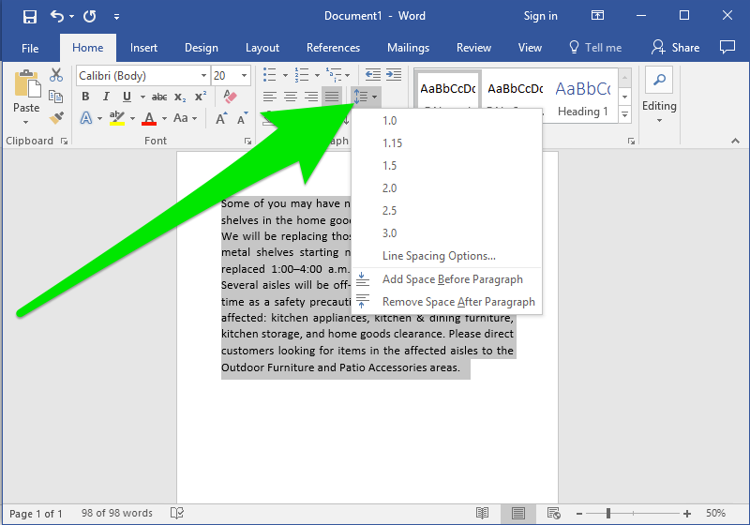

* Paragraph Indentation: Indent paragraphs for better organization.

Example:

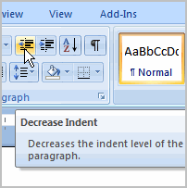

* Bullet Points and Numbering: Create lists with bullet points or numbers
* Example:
* 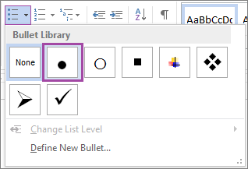
* **Page Orientation:** Choose between portrait and landscape orientation.

Example:

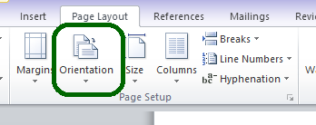

* **Page Size:** Select the paper size (e.g., A4, Letter).
* **Example:**

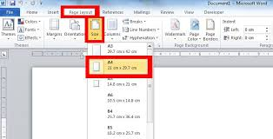

* **Shapes:** Insert shapes like rectangles, circles, and arrows.

***Example:***

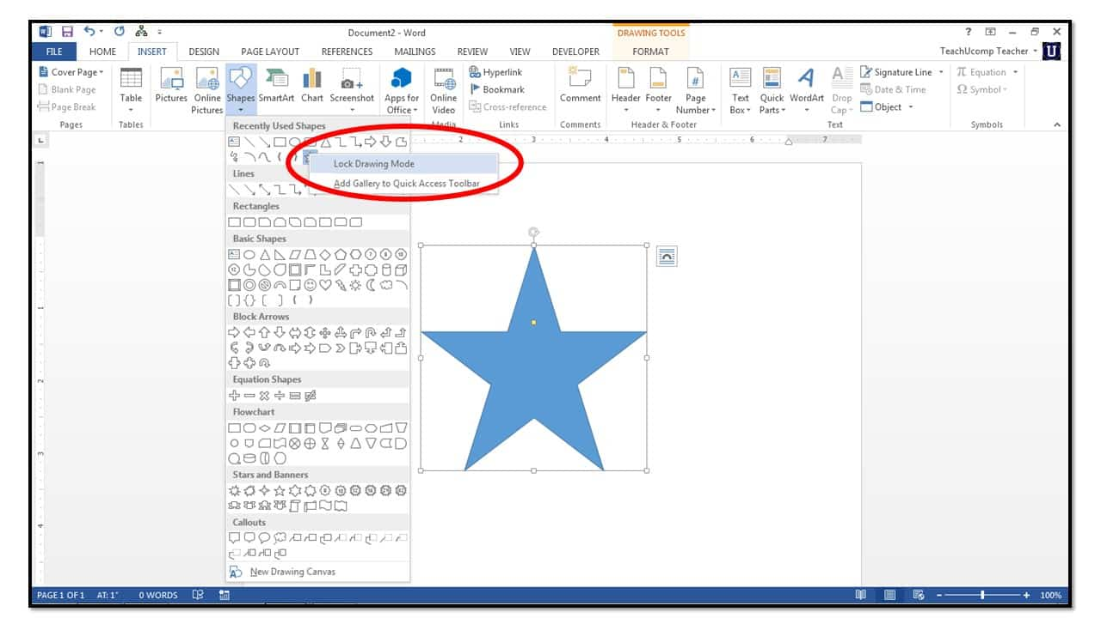

* **SMART ART** : Smart art Create diagrams and charts.

***Example:***

* Hyperlinks: Add links to websites or other documents.

➢ Editing and Reviewing:

* Find and Replace: Search for and replace specific text.
* Example:

* 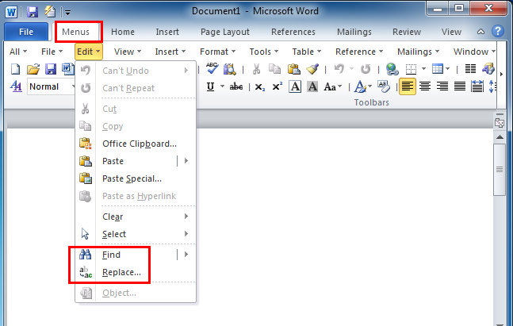

* **Macros:** Record and automate 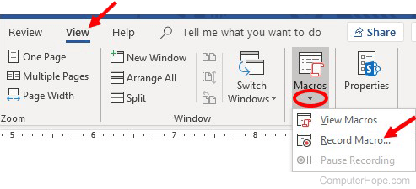repetitive tasks.
* **Example**

**LAB 5**

 **Mail Merge**: A Powerful Tool for Personalized Documents Mail merge is a feature in Microsoft Word that allows you to create personalized documents in bulk. It involves combining a main document

with a data source to produce multiple documents, each customized with specific information from the data source. ➢ Common Use Cases:

* Personalized Letters: Create personalized letters to clients or customers.
* Mailing Labels: Generate mailing labels with addresses from a database.
* Envelopes: Print envelopes with recipient addresses.
* Certificates: Create personalized certificates with recipient names and other details.

➢ Benefits of Mail Merge:

Mail merge is a powerful feature used in word processing and spreadsheet applications to automate the creation of personalized documents such as letters, emails, labels, and envelopes. By integrating data from a source (e.g., a spreadsheet or database) into a template document, mail merge simplifies and streamlines the process of creating customized communication for large audiences. Here are the primary benefits of using mail merge:

**1. Time Efficiency**

• **Streamlined Process:**

Mail merge automates the process of personalizing individual letters or emails by inserting specific data fields (like names, addresses, or order details) into a template.

• **Bulk Processing:**

Instead of manually creating each document or email, a single template and data file can generate hundreds or thousands of personalized outputs, saving significant time.

* **Mail Merge:** Create personalized documents, like letters or labels,using adata source.
* **Example:**
* 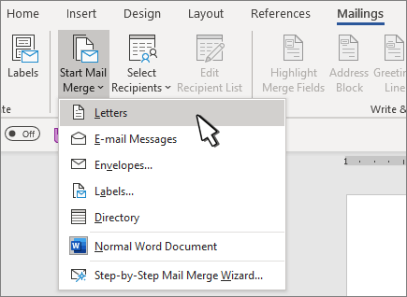
*  **Table of contents:**

A table of contents (TOC) is a list of the sections or chapters within a document, along with their corresponding page numbers. It's like a roadmap that helps readers navigate through the document quickly and easily.

**➢ Key features of a table of contents:**

* Organization:
* It provides a clear overview of the document's structure.
* Navigation:
* It allows readers to quickly locate specific sections.
* Clarity:
* It improves the readability and comprehension of the document
* **.➢ How to create a table of contents:** 
  1. Structure your document: Organize your document into sections and subsections, using headings and subheadings.
  2. Apply heading styles: Assign appropriate heading styles to your sections and subsections.
  3. Insert the table of contents: Use your word processing software's built-in feature to automatically generate a table of contents based on the heading styles.

**➢ Section Breaks**

Section breaks are used to divide a document into separate sections. This allows you to apply different formatting, page numbering, headers, and footers to each section.

* Next Page: Starts a new section on the next page.
* Continuous: Starts a new section on the same page. Useful for changing the number of columns.
* Odd Page: Starts a new section on the next odd-numbered page.
* Even Page: Starts a new section on the next even-numbered page.
* **➢ References**

References are citations to sources used in your document. They can be in the form of footnotes, endnotes, or a bibliography. References help you give credit to the original authors and provide credibility to your work.

* **Running headers:** Repeat a title or heading on each page.

* **Author names:** Include author names on each page.
* **Company logos:** Add a company logo to the header or footer.

By effectively using section breaks, references, and headers and footers, you can create well-structured and professional-looking documents**.**

**LAB 6**

* **MENDELEY:**

Mendeley Reference Manager is a free web and desktop reference management application. It helps you simplify your reference management workflow so you can focus on achieving your goals. With Mendeley

Reference Manager you can: Store, organize and search all your references from just one library.

**GRAMMARLY:**

Grammarly is an AI-powered writing tool that helps improve grammar, spelling, and writing style.

**PDF Element:**

PDF element is a PDF editor and converter tool from Wondershare that allows users to read, edit, convert, annotate, sign, and share PDFs. It can help users produce high-quality PDF documents and forms quickly, affordably, and securely.

**AUTOMATION WITH MACROS:**

Automation with macros creates and runs small programs that record and replay a sequence of actions to automate repetitive tasks:

**What macros are?**

Macros are small programs that record a series of actions, such as keystrokes and mouse clicks, to complete a task.

**How macros are used?**

You can run a macro to replay the recorded actions with a single click To convert a PDF to a Word document, you can use Adobe Acrobat or a free online converter:

**Adobe Acrobat**

* + - 1. Open the PDF in Acrobat
      2. Select Convert from the global bar
      3. Select DOC from the drop-down menu next to Microsoft Word
      4. Select Convert to DOC
      5. Choose a location to save the file and select Save

**PDF TO WORD CONVERSION:**

* + - 1. Select a PDF file
      2. Acrobat will automatically convert the file to a Word document
      3. Download your file

Convert PDF to Word: A free online converter | Adobe Acrobat.

**REFRENCING TOOLS:**

Reference books and materials are research tools that provide quick information on a topic. Some types include encyclopedias, dictionaries, almanacs, and directories.

**CITATIONS:**

A citation is a way to credit the original source of information, ideas, or images used in a research paper or other project.

**Citation Management Tools:**

**Mendeley** 1.: A free reference manager that helps organize citations and bibliographies.

**Zotero:** An open-source citation management tool that integrates with word processors.

**EndNote**: A commercial citation management tool popular among researchers.

.

**LAB 7**

**MAIL MANAGEMENTS:**

**Mail Management Tools**

1. **Microsoft Outlook**: A popular email client that includes features like email organization, calendaring, and task management.

2. **Gmail**: A free email service provided by Google that includes features like email labeling, filtering, and prioritization.

3. **Mailchimp**: An email marketing platform that allows users to create and manage email campaigns, automate emails, and track email performance.

Mail Management Techniques

1. **Inbox Zero**: A technique that involves regularly clearing out your inbox by responding, delegating, or archiving emails.

2. **Email Filtering**: A technique that involves setting up filters to automatically sort, prioritize, or delete emails based on specific criteria.

3. **Batching**: A technique that involves grouping similar emails together and responding to them in batches, rather than individually.

Best Practices for Mail Management

1. **Use Clear and Concise Subject Lines**: Use descriptive subject lines that accurately summarize the content of the email.

2. **Use Proper Email Etiquette**: Use proper grammar, spelling, and punctuation in emails, and avoid using all caps or overly casual language.

3. **Avoid Overusing CC and BCC:** Only use CC and BCC when necessary, and avoid using them to send emails to large groups of people.

4. **Use Email Signatures**: Use email signatures to include important contact information, such as your name, title, and phone number.

5. **Regularly Back Up Emails:** Regularly back up emails to prevent data loss in case of technical issues or account cancellations.

Mail Management Software Features

1. **Email Organization**: Features like folders, labels, and categories to help organize emails.

2. **Email Prioritization**: Features like flags, stars, or priority levels to help prioritize emails.

3. **Email Automation**: Features like auto-responders, email templates, and automated workflows to help streamline email management.

4. **Email Integration:** Features like integration with calendars, contacts, and tasks to help manage email and other productivity tools.

5. **Email Security**: Features like spam filtering, virus scanning, and encryption to help protect emails from security threats.

**LAB 8**

**INTRODUCTION TO EXCEL:**

What is Excel?

Microsoft Excel is a spreadsheet software used for data analysis, visualization, and calculation. It's widely used in various industries, including business, finance, and education.

Basic Excel Skills:

1. Creating a New Workbook: To start working in Excel, you need to create a new workbook. Go to File > New > Workbook.

2. Understanding the Excel Interface: The Excel interface consists of rows, columns, and cells. Rows are labeled with numbers (1, 2, 3, etc.), while columns are labeled with letters (A, B, C, etc.).

3. Entering Data: To enter data into a cell, simply click on the cell and type in your data.

4. Basic Arithmetic Operations: Excel allows you to perform basic arithmetic operations like addition, subtraction, multiplication, and division.

5. Formatting Cells: You can format cells to change their appearance, such as font, color, and alignment.

6. Basic Functions: Excel has various built-in functions, such as SUM, AVERAGE, and COUNT, which can be used to perform calculations.

7. Creating Charts and Graphs: Excel allows you to create various charts and graphs to visualize your data.

Basic Excel Formulas:

1. SUM Formula: =SUM(range) - Adds up a range of cells.

2. AVERAGE Formula: =AVERAGE(range) - Calculates the average of a range of cells.

3. COUNT Formula: =COUNT(range) - Counts the number of cells in a range that contain numbers.

4. PRODUCT Formula:=PRODUCT(range) – product of range of cells.

5. TODAY Formula:=TODAY(range) – date of today

6. MAX Formula:=MAX(range) – maximum value from the table.

7.CONCATENATE Formula:=CONCATENATE(range ”range”,) – Write first and last names together.

8. Basic Arithmetic Formulas: =A1+B1, =A1-B1, =A1*B1, =A1/B1 - Performs basic arithmetic operations on cells.

Basic Excel Shortcuts:

1. Ctrl+S: Saves the workbook.

2. Ctrl+Z: Undoes an action.

3. Ctrl+Y: Redoes an action.

4. Ctrl+C: Copies a cell or range.

5. Ctrl+V: Pastes a cell or range.

6. Ctrl+A: Selects all cells in a worksheet.

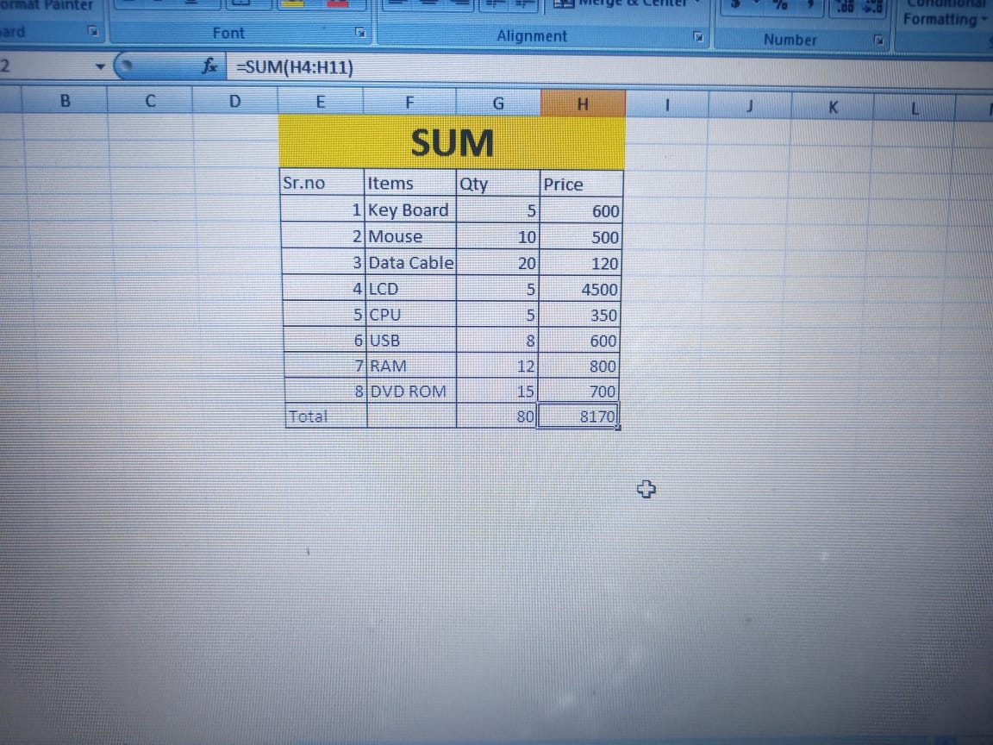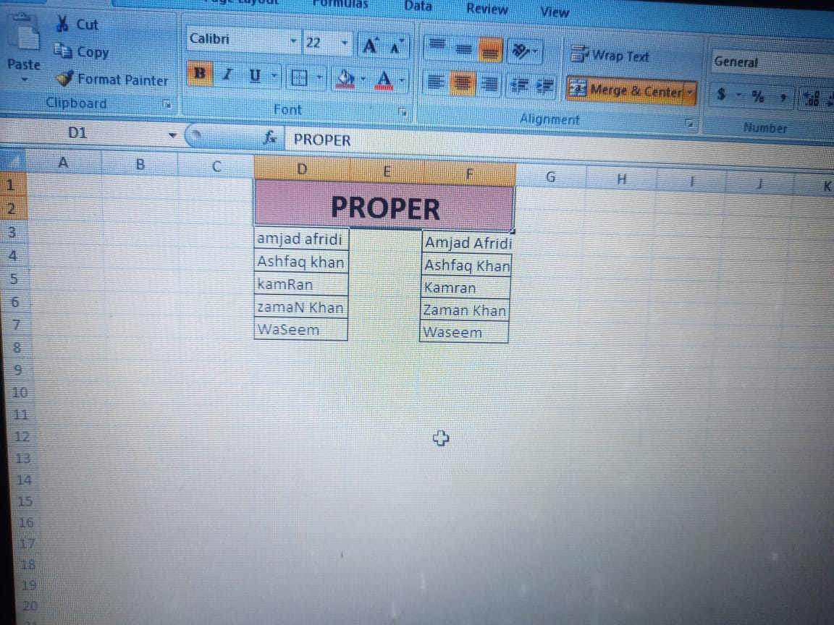

**INTRODUCTION TO CELL REFRENCES:**

Cell referencing is a fundamental concept in spreadsheet software like Microsoft Excel, Google Sheets, and LibreOffice Calc. It allows you to create formulas and functions that reference specific cells or ranges of cells.

# Types of Cell References

1. Relative Reference: A relative reference refers to a cell or range of cells relative to the current cell. For example, if you enter "=A1" in cell B2, the formula will reference the value in cell A1.

2. Absolute Reference: An absolute reference refers to a specific cell or range of cells, regardless of the current cell. For example, if you enter "=$A$1" in cell B2, the formula will always reference the value in cell A1.

3. Mixed Reference: A mixed reference combines relative and absolute references. For example, if you enter "=A$1" in cell B2, the formula will reference the value in the cell in column A and row 1, regardless of the current cell.

# Cell Reference Operators

1. Range Operator: The range operator (:) is used to specify a range of cells. For example, "=A1:B2" references the range of cells from A1 to B2.

2. Union Operator: The union operator (,) is used to combine multiple cell references. For example, "=A1,B2" references the cells A1 and B2.

3. Intersection Operator: The intersection operator (space) is used to specify the intersection of two ranges. For example, "=A1:B2 C1:C2" references the cells that are common to both ranges.

**INTRODUCTION TO SORTING AND FILTERING DATA:**

Sorting and filtering data are essential skills in data analysis and management. Here's an introduction to these concepts:

Sorting Data

Sorting data involves arranging a list of items in a specific order, such as alphabetical, numerical, or chronological. Sorting helps to:

1. Organize data for easier analysis

2. Identify patterns and trends

3. Simplify data visualization

Types of Sorting

1. Ascending Order: Sorting data from smallest to largest (e.g., A-Z, 1-10)

2. Descending Order: Sorting data from largest to smallest (e.g., Z-A, 10-1)

Filtering Data

Filtering data involves selecting a subset of data based on specific criteria, such as values, dates, or categories. Filtering helps to:

1. Focus on specific data points

2. Exclude irrelevant data

3. Improve data visualization

Types of Filtering

1. Value Filtering: Filtering data based on specific values (e.g., show only rows where column A = "yes")

2. Date Filtering: Filtering data based on specific dates or date ranges (e.g., show only rows where date column is between 2020-01-01 and 2020-12-31)

3. Category Filtering: Filtering data based on specific categories (e.g., show only rows where column B = "category 1")

Tools for Sorting and Filtering Data

1. Microsoft Excel: Excel provides various sorting and filtering options, including the "Sort & Filter" button and the "Filter" function.

2. Google Sheets: Google Sheets offers similar sorting and filtering options, including the "Sort & Filter" button and the "Filter" function.

3. Data Analysis Software: Specialized data analysis software, such as Tableau or Power BI, often provide advanced sorting and filtering capabilities.

**LAB 9**

Data visualization is the process of creating graphical representations of data to better understand and communicate insights. Advanced features in data visualization tools enable users to create more complex and interactive visualizations.

Types of Data Visualization

1. Bar charts: Compare categorical data across different groups.

2. Line charts: Show trends over time or across categories.

3. Scatter plots: Visualize relationships between two continuous variables.

4. Pie charts: Display proportional data.

5. Heatmaps: Show relationships between two categorical variables.

6. Interactive visualizations: Allow users to explore data in real-time.

Advanced Features in Data Visualization

1. Drill-down capabilities: Enable users to explore detailed data.

2. Filtering and sorting: Allow users to narrow down data.

3. Animation and transitions: Enhance the visual appeal of visualizations.

4. Geospatial visualization: Display data on maps.

5. Real-time data updates: Reflect changes in data as they occur.

6. Collaboration tools: Enable multiple users to work on visualizations together.

Tools for Data Visualization

1. Tableau: A popular data visualization platform.

2. Power BI: A business analytics service by Microsoft.

3. D3.js: A JavaScript library for producing dynamic, interactive data visualizations.

4. Matplotlib: A Python library for creating static, animated, and interactive visualizations.

5. Seaborn: A Python library based on Matplotlib that provides a high-level interface for drawing attractive and informative statistical graphics.

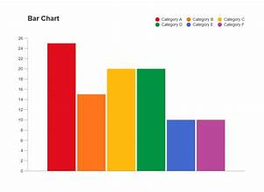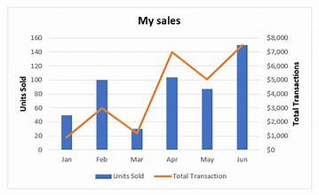

**CONDITIONAL FORMATING:**

Conditional formatting is a powerful tool in spreadsheet software that allows you to highlight cells based on specific conditions. Here's an overview:

Types of Conditional Formatting

1. Value-based formatting: Highlight cells based on their values, such as numbers, text, or dates.

2. Formula-based formatting: Highlight cells based on a formula or condition, such as "greater than" or "less than".

3. Top/bottom formatting: Highlight cells that are in the top or bottom percentage of a range.

4. Data bars: Display data bars to visualize data distribution.

5. Color scales: Display color scales to visualize data distribution.

How to Apply Conditional Formatting

1. Select the range: Select the range of cells you want to format.

2. Go to Home tab: Click on the "Home" tab in your spreadsheet software.

3. Click on Conditional Formatting: Select "Conditional Formatting" from the dropdown menu.

4. Choose a rule: Choose a rule type (e.g., "Value", "Formula", "Top 10%").

5. Set the condition: Set the condition for the rule (e.g., "greater than 10").

6. Choose a format: Choose a format for the highlighted cells (e.g., fill color, font color).

Advanced Conditional Formatting Techniques

1. Multiple conditions: Use multiple conditions to create complex formatting rules.

2. Nested formulas: Use nested formulas to create complex formatting rules.

3. Dynamic formatting: Use dynamic formatting to update formatting rules based on changing data.

**CREATION OF BAR CODE:**

Types of Barcodes

1. UPC (Universal Product Code): Used for retail products.

2. EAN (European Article Number): Used for retail products in Europe.

3. Code 128: Used for shipping and inventory tracking.

4. QR Code: Used for mobile payments, marketing, and inventory tracking.

Steps to Create a Barcode

1. Determine the type of barcode: Choose the type of barcode that suits your needs.

2. Gather the necessary data: Collect the data that will be encoded in the barcode, such as the product number or inventory number.

3. Use a barcode generator software: Utilize a barcode generator software, such as Barcode Generator or Zebra Barcode Generator, to create the barcode.

4. Customize the barcode: Adjust the barcode's size, color, and resolution to suit your needs.

5. Test the barcode: Verify that the barcode can be scanned correctly using a barcode scanner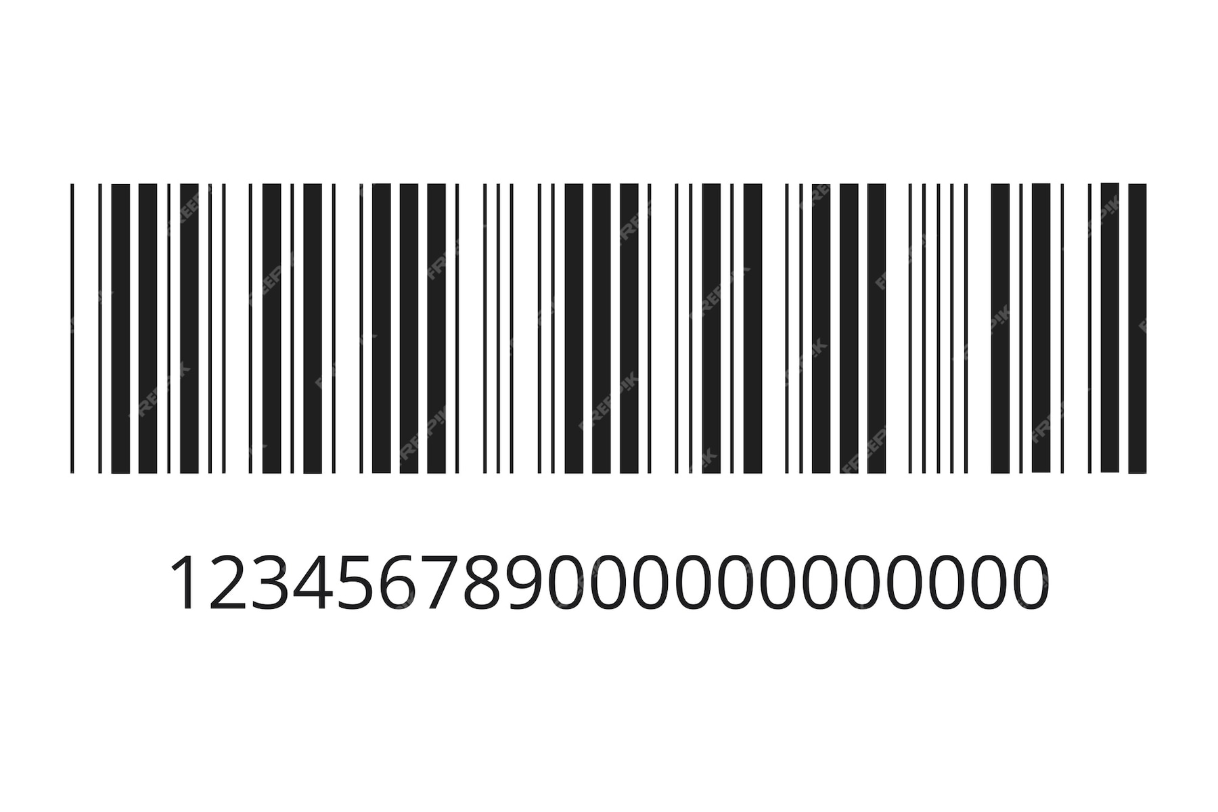

**CREATING QR CODE:**

Creating a QR code is a straightforward process that can be done using various online tools or software. Here's a step-by-step guide on how to create a QR code:

Types of QR Codes

1. Static QR Code: A static QR code contains fixed information that cannot be changed once the QR code is generated.

2. Dynamic QR Code: A dynamic QR code can be edited and updated even after the QR code is generated.

Steps to Create a QR Code

1. Choose a QR Code Generator: Select a reliable QR code generator tool, such as QR Code Monkey, GoQR.me, or QR Stuff.

2. Enter the Desired Information: Input the information you want to encode in the QR code, such as a URL, text, email, or phone number.

3. Customize the QR Code: Adjust the QR code's design, color, and size to suit your needs.

4. Download the QR Code: Save the generated QR code as an image file (e.g., PNG, JPEG, or SVG).

5. Test the QR Code: Verify that the QR code can be scanned correctly using a smartphone or QR code scanner.



**FREQUENCY FUNCTION AND STASTICAL ANALYSIS FUNCTION:**

The frequency function and statistical analysis functions are essential tools in data analysis.

Frequency Function

The frequency function, also known as the COUNTIF function in Excel, calculates the number of cells within a range that meet a specific condition.

Syntax:

COUNTIF(range, criteria)

Example:

COUNTIF(A1:A10, ">5")

This formula counts the number of cells in the range A1:A10 that contain a value greater than 5.

Statistical Analysis Functions

Statistical analysis functions help you understand and describe your data.

Types of Statistical Analysis Functions:

1. AVERAGE: Calculates the average of a set of values.

2. MEDIAN: Finds the middle value in a set of values.

3. MODE: Returns the most frequently occurring value in a set of values.

4. STDEV: Calculates the standard deviation of a set of values.

5. VARIANCE: Calculates the variance of a set of values.

6. CORREL: Calculates the correlation coefficient between two sets of values.

7. REGRESS: Performs linear regression analysis on a set of values.

Example:

=AVERAGE(A1:A10)

This formula calculates the average of the values in the range A1:A10.

**LAB 10**

**INTRODUCTION TO PIVOT TABLES:**

Pivot tables are a powerful tool in data analysis that allows you to summarize, analyze, and visualize large datasets. Here's an introduction to pivot tables:

What is a Pivot Table?

A pivot table is a data summarization tool that allows you to rotate and aggregate data from a spreadsheet or database. It enables you to analyze and visualize data from multiple perspectives, making it easier to identify trends, patterns, and insights.

Benefits of Pivot Tables

1. Data summarization: Pivot tables allow you to summarize large datasets, making it easier to analyze and understand the data.

2. Data analysis: Pivot tables enable you to analyze data from multiple perspectives, making it easier to identify trends, patterns, and insights.

3. Data visualization: Pivot tables allow you to create interactive and dynamic visualizations, making it easier to communicate insights and findings.

4. Flexibility: Pivot tables enable you to easily switch between different data views, making it easier to explore and analyze data.

Key Components of a Pivot Table

1. Row labels: The row labels are the unique values in the dataset that are used to create the rows of the pivot table.

2. Column labels: The column labels are the unique values in the dataset that are used to create the columns of the pivot table.

3. Values: The values are the data points that are summarized and analyzed in the pivot table.

4. Filters: The filters are used to narrow down the data in the pivot table, making it easier to analyze and visualize specific subsets of data.

Common Pivot Table Operations

1. Summarize: Summarize data by grouping it by row labels, column labels, or both.

2. Filter: Filter data to narrow down the data in the pivot table.

3. Sort: Sort data in ascending or descending order.

4. Group: Group data by row labels or column labels.

5. Pivot: Pivot data to switch between different data views.

**VLOOKUP:**

VLOOKUP (Vertical Lookup) is a function that allows you to search for a value in a table and return a corresponding value from another column.

**Syntax**

VLOOKUP (lookup_value , table array, col_index_num, [range_lookup])

**Example**

VLOOKUP (A2, B:C, 2, FALSE)

This formula searches for the value in cell A2 in the first column of the range B:C and returns the corresponding value in the second column.

**HLOOKUP**

HLOOKUP (Horizontal Lookup) is a function that allows you to search for a value in a table and return a corresponding value from another row.

**Syntax**

HLOOKUP(lookup_value, table_array, row_index_num, [range_lookup])

**Example**

HLOOKUP(A2, B:C, 2, FALSE)

This formula searches for the value in cell A2 in the first row of the range B:C and returns the corresponding value in the second row.

**INTRODUCTION TO MACROS:**

Macros are a powerful tool in Excel that allow you to automate repetitive tasks, simplify complex processes, and create custom solutions.

What is a Macro?

A macro is a set of instructions that are recorded or written in a programming language, such as Visual Basic for Applications (VBA). Macros can be used to perform a wide range of tasks, including:

1. Automating repetitive tasks

2. Simplifying complex processes

3. Creating custom solutions

4. Interacting with other Excel features, such as charts and pivot tables

Types of Macros

1. Recorded Macros: These are macros that are recorded by Excel as you perform a task. Recorded macros are useful for simple tasks, but they can be limited in their functionality.

2. Written Macros: These are macros that are written in a programming language, such as VBA. Written macros offer more flexibility and power than recorded macros.

Benefits of Macros

1. Increased Productivity: Macros can automate repetitive tasks, freeing up time for more complex and creative work.

2. Improved Accuracy: Macros can reduce errors by automating tasks and ensuring consistency.

3. Customization: Macros can be used to create custom solutions that meet specific business needs.

4. Flexibility: Macros can be used to interact with other Excel features, such as charts and pivot tables.

How to Create a Macro

1. Open the Visual Basic Editor: Press Alt + F11 or navigate to Developer > Visual Basic in the Excel ribbon.

2. Create a New Module: Insert > Module or press Alt + F11 and then Insert > Module.

3. Write or Record the Macro: Write the macro code in the Visual Basic Editor or record the macro by performing the task.

4. Save the Macro: Save the macro by clicking File > Save or pressing Ctrl + S.

**ANALYZE AND VISUALIZE DATA SET USING SKILLS:**

Let's analyze and visualize a sample dataset using the skills learned throughout the course.

Dataset:

We'll use a sample dataset that contains information about sales data for a company. The dataset includes the following columns:

1. Region: The region where the sale was made (e.g., North, South, East, West)

2. Product: The product that was sold (e.g., Product A, Product B, Product C)

3. Sales: The total sales amount for each region and product

4. Date: The date when the sale was made

Analysis:

Let's perform some analysis on the dataset:

1. Summary Statistics: Calculate the total sales, average sales, and standard deviation of sales for each region and product.

2. Data Visualization: Create a pivot table to visualize the sales data by region and product.

3. Trend Analysis: Use a line chart to visualize the sales trend over time for each region and product.

Visualization:

Let's create some visualizations to help us understand the data better:

1. Pivot Table: Create a pivot table to show the total sales by region and product.

| Region | Product | Total Sales |

| --- | --- | --- |

| North | Product A | 1000 |

| North | Product B | 2000 |

| South | Product A | 1500 |

| South | Product B | 3000 |

| ... | ... | ... |

1. Bar Chart: Create a bar chart to show the total sales by region.

| Region | Total Sales |

| --- | --- |

| North | 3000 |

| South | 4500 |

| East | 2000 |

| West | 3500 |

1. Line Chart: Create a line chart to show the sales trend over time for each region.

| Date | North | South | East | West |

| --- | --- | --- | --- | --- |

| Jan | 1000 | 1500 | 500 | 1000 |

| Feb | 1200 | 1800 | 600 | 1200 |

| Mar | 1500 | 2000 | 700 | 1500 |

| ... | ... | ... | ... | ... |

Insights:

From the analysis and visualizations, we can gain the following insights:

1. Regional Sales: The South region has the highest total sales, followed by the North region.

2. Product Sales: Product B has the highest total sales, followed by Product A.

3. Sales Trend: The sales trend over time shows an increasing trend for all regions, with the South region showing the highest growth rate.

Conclusion:

By analyzing and visualizing the sales data, we can gain valuable insights into regional and product sales, as well as sales trends over time. These insights can help inform business decisions, such as resource allocation and marketing strategies.

**CANVA:**

Canva is a popular graphic design platform that allows users to create a wide range of visual content, including social media graphics, presentations, infographics, and more. Here's a step-by-step guide on how to use Canva:

Getting Started

1. Sign up for a Canva account: Go to (link unavailable) and sign up for a free account.

2. Choose a design type: Select the type of design you want to create, such as a social media graphic, presentation, or infographic.

Designing with Canva

1. Select a template: Browse Canva's template library and select a template that matches your design type.

2. Customize the template: Use Canva's drag-and-drop editor to customize the template. Add text, images, shapes, and other elements to your design.

3. Use the toolbar: Use the toolbar at the top of the screen to access various design tools, such as font, color, and alignment options.

4. Add images and graphics: Use Canva's image library or upload your own images to add to your design.

5. Experiment with fonts: Use Canva's font library to select from a wide range of fonts and font styles.

Working with Text

1. Add text: Click on the text icon in the toolbar to add text to your design.

2. Format text: Use the text formatting options in the toolbar to change font, size, color, and alignment.

3. Create a text box: Use the text box tool to create a text box and add text to it.

Working with Images

1. Upload images: Click on the upload icon in the toolbar to upload your own images to Canva.

2. Use Canva's image library: Browse Canva's image library to select from a wide range of images and graphics.

3. Resize and crop images: Use the image editing tools in the toolbar to resize and crop images.

Saving and Sharing

1. Save your design: Click on the save icon in the toolbar to save your design.

2. Download your design: Click on the download icon in the toolbar to download your design as a PNG, JPG, or PDF file.

3. Share your design: Click on the share icon in the toolbar to share your design on social media or via email.

